**APPENDIX 1**

**Online Job Application portal**

END TERM REPORT

*By*

**PARISA VINAY**

(Section: K19PV___)

(Roll Number(s): 08)

(Registration Number(s): 11901947)

**TUMMETI SAI RAM KUMAR**

(Section: K19PV___)

(Roll Number(s): 46)

(Registration Number(s): 11910846)



**Department of Intelligent Systems, School Of Computer Science Engineering Lovely Professional University, Jalandhar November-2020**

**Student Declaration**

This is to declare that this report has been written by me/us. No part of the

report is copied from other sources. All information included from other sources has been duly acknowledged. I/We aver that if any part of the report is found to be copied, I/we shall take full responsibility for it.

Parisa Vinay

Roll Number -08

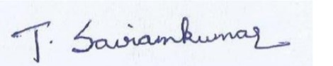

Tummeti . Sai Ram Kumar

Roll Number – 46

Place- Jalandhar

Date 31-10-2020.

**TABLE OF CONTENTS**

**TITLE PAGE NO.**

**1. Introduction ................ 5**

1.1 Background 5

1.2 Motivation 5

1.3 The Outcome of the project 5

1.4 Concrete Goal 6

1.5 Objective 6

**2. Description of Project ... .................. 8**

2.1 Description of work division 8

2.2 Implementation of scheduled work 8

2.3 Steps for creating online job application portal

8

2.3.1 Import pygame and random module 8

2.3.2 Module for graphics 8

2.3.3 Module for dice image 9

2.3.4 Module for Introduction Image 9

2.3.5 Module for sound 9

2.3.6 Module for ladders 10

2.3.7 Module for snakes 10

2.3.8 Module for dice 11

2.3.9 Module for quit 11

2.3.10 Module for Main Menu 12

2.3.11 Module for choice or options 12

2.3.12 Module for playing a game 13

2.4 Output of the Program 16

2.5 Technologies and Frameworks used

18

2.6 SWOT Analysis 18

APPENDIX 4

BONAFIDE CERTIFICATE

Certified that this project report “ONLINE JOB APPLICATION PORTAL” is the bonafide work of “PARISA VINAY , TUMMETI SAI RAM KUMAR ” who carried out the project work under my supervision.

Dr.Dhanpratap Singh

Professor ID- 25706

Department Of Intelligent System

**1.Introduction**

A Snakes and Ladder Game is a traditional board game played by one to four people. The game is based on the movement of the characters of these players along with numbered boxes and the first character to get to the last box wins. The players’ characters progress by throwing a die, the number on the die determines how many boxes the player moves. There are snakes and ladders on the way; snakes take a character backward (or downwards) while the ladders lift up the characters thereby adding a fun twist to the lucks of the character

**1.1 Background**

Snakes and Ladders Game is developed in Python Programming Language and it is a desktop application. This project system used a Pygame and Random module. Pygame is a cross-platform set of Python modules designed for writing video games. This is the game between the computer and the user.

**1.2 Motivation**

We felt motivated by the idea of the project to make students develop a game that makes students be more interested in programming. And our project “Snakes and Ladders” is a fun game that we played in our childhood made us even more motivated to complete the project.

**1.3 The outcome of the Project**

The game supports both single-player and multi-player. The game consists of a board with boxes numbered till 100. And the boxes consist of ladders and snakes and the players should cross all the snakes with help of ladders. Players should use dice to move from one box to another. Each player has one chance each. And if a user gets 6 as dice face he has another chance to throw. And ladders help players to up and snakes pushes the players down. The first player who finishes the game wins the game.

**1.4 Concrete Goal**

The goal is to create a program with all the rules and the functions of the original snake and ladder game. And also support the game with single and multiplayer and also with CPU. And to make players comfort we added background music and a better user interface and good animation.

**1.5 Objective**

To use the different user-defined functions, to break a program into many simplified parts to deal with, and to make it easier to understand the codes too.

To promote the use of an array in general programming for a simplified version of the program.

To apply the file handling concepts in order to retrieve the player’s data files that contain the

data of the players.

To use minimum graphics as far as possible to make the program execute fast but also user-friendly side by side.

To use the general concept of python language to develop simple snakes and ladders game that as a whole entertains the user.

**1.6 Description of Project**

This project system used a Pygame and Random module. Pygame is a cross-platform set of Python modules designed for writing video games. This is the game between the computer and the user.

This Snakes and Ladders contain python file s resource files and sound files. The gameplay

of the system, which is the user can choose an option either to play multiple participants or with the computer.

Beginning of the game, the player needs to roll the dice and in the wake of moving it, the

game moves the token consequently as indicated by the dice number. The interactivity is like the genuine one. Here, the player likewise gets one more opportunity to roll the dice at whatever point he/she gets 6 numbers.

There are quantities of stepping stools and snakes in the game which causes the player to update or minimization the square number. The player who arrives at the last square of the rack is the champ.

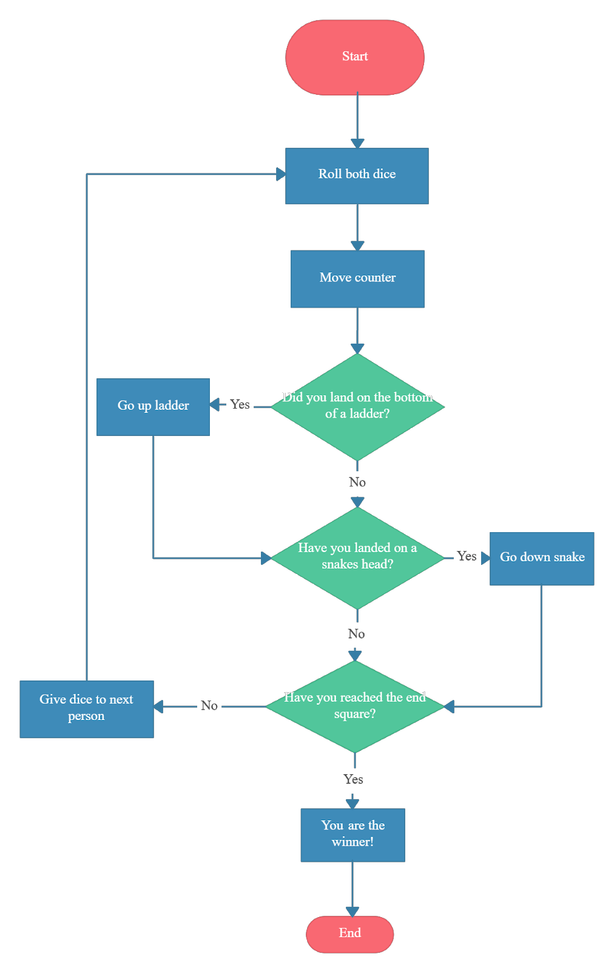

**2.Description of Project**

**2.1 Description of work division**

Our team consists of 3 members. They are Perumalla Litesh, Ankit Rajpoot, Bhupendra

Singh.

Perumalla Litesh (Team Member) is responsible for writing the report of the project work. Ankit Rajpoot (Leader) is responsible for writing the program for the project and debugging. Bhupendra Singh (Team Member) is responsible for the User Interface, Graphical Interface of the Project.

**2.2 Implementation of scheduled work**

Firstly, we started with a basic code of the program Ankit started writing the source code of the program, and after finishing the source code. Next, Bhupendra Singh started his work by implementing the user interface, graphical interface, and Background Music for the program. Lastly, Litesh completed the project report.

**2.3 Steps for creating snakes and Ladders game**

**Step 1:** Create a project and create a python file.

**Step 2:** The actual code

**2.3.1 Import Random module and Pygame module**



The code above which is random() function, which generates random numbers between 0 and

1. And the pygame library is an open-source module for the python programming language specially intended to help you make games and other multimedia applications. Pygame can run across many platforms and operating systems.

**2.3.2 Module for graphics**

The code given below which is for the graphics color used in a text in the snakes and ladders project.

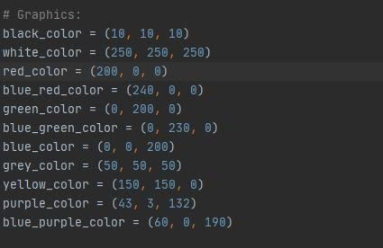

**2.3.3 Module for Dice Image**

The code given below is the dice image used in the game.

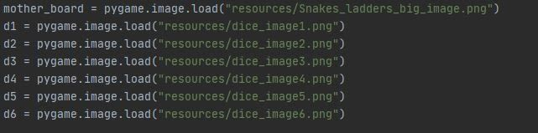

**2.3.4 Module for Introduction Image**

The code given below which is for the introduction image used in the snakes and ladders game.

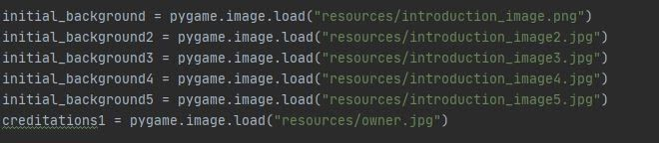

**2.3.5 Module for sound**

The code given below is the background music which is used in the snakes and ladders game.

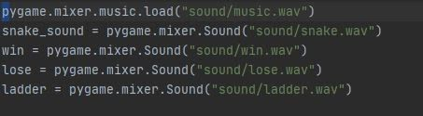

**2.3.6 Module for ladders**

The code given below is the function of ladders use in a system.

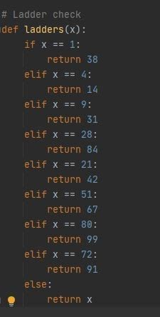

**2.3.7 Module for snakes**

The code given below which is the function for snakes in a system.

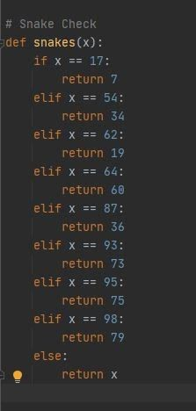

**2.3.8 Module for dice**

The code given below which is for the function of the number of dice used in a system

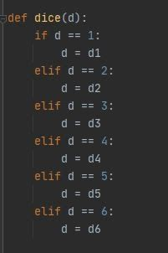

**2.3.9 Module for quit**

The code given below which is for the function for exit/quit in a game.

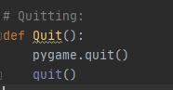

**2.3.10 Module for Main Menu**

The code given below is for the function of the main menu in a system.

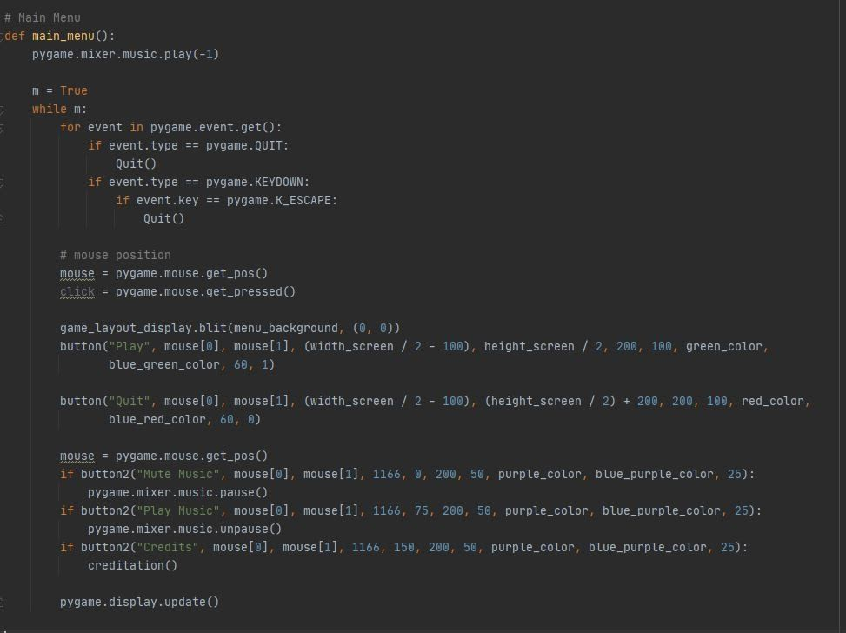

**2.3.11 Module for choice or options for players**

The code given below is for the function of players that you want to choose either single-player, two-player, three-player or four players and its color design.

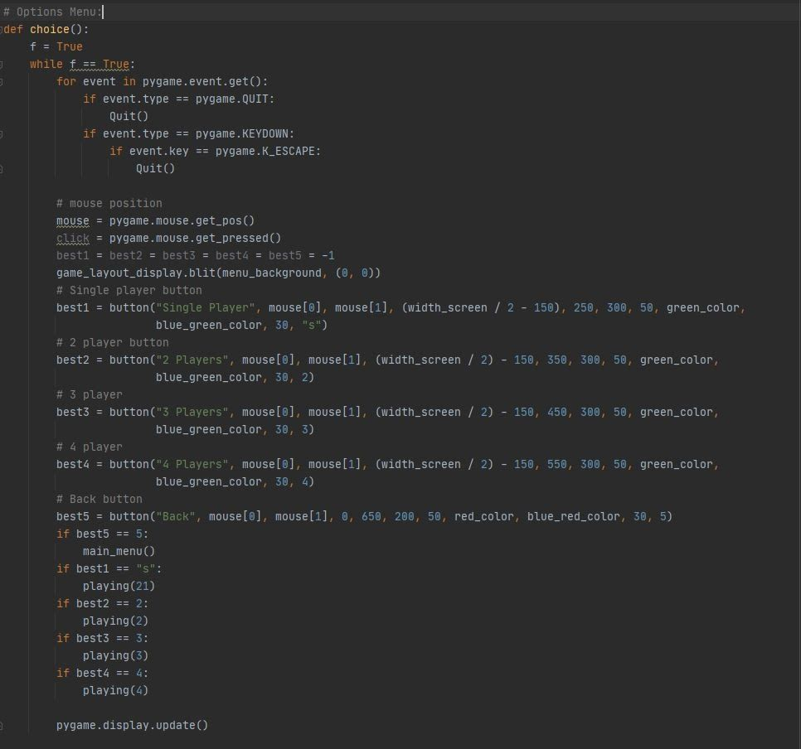

**2.3.12 Module for playing a game**

The code given below is for the function of all players you choose in a game

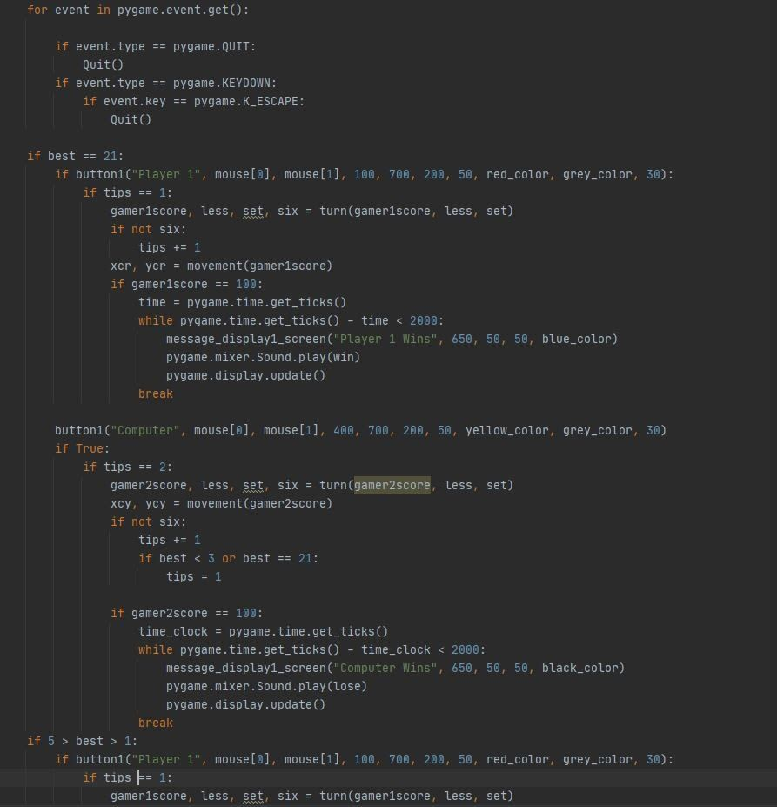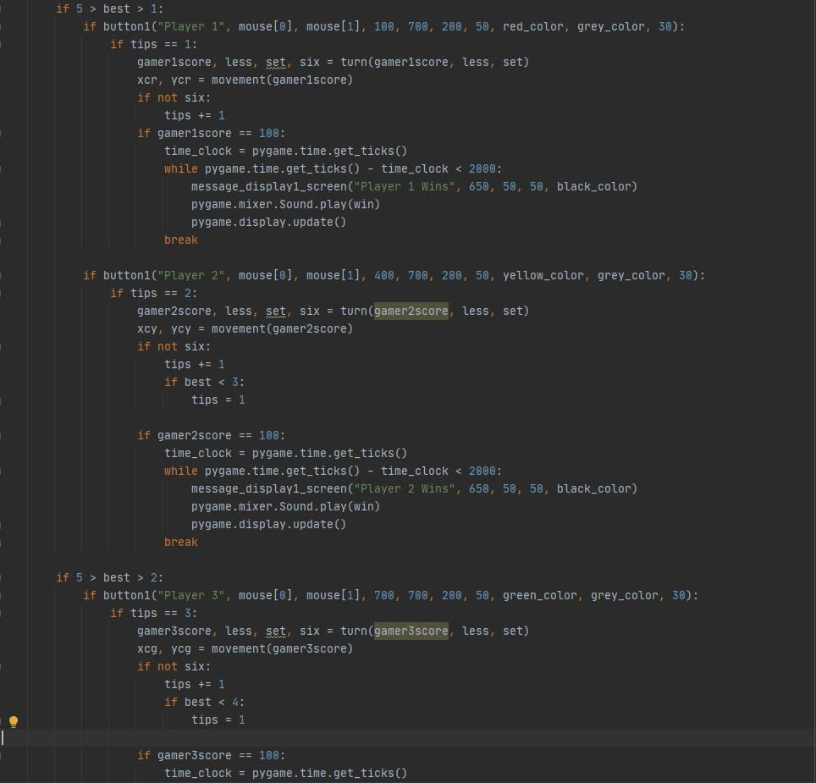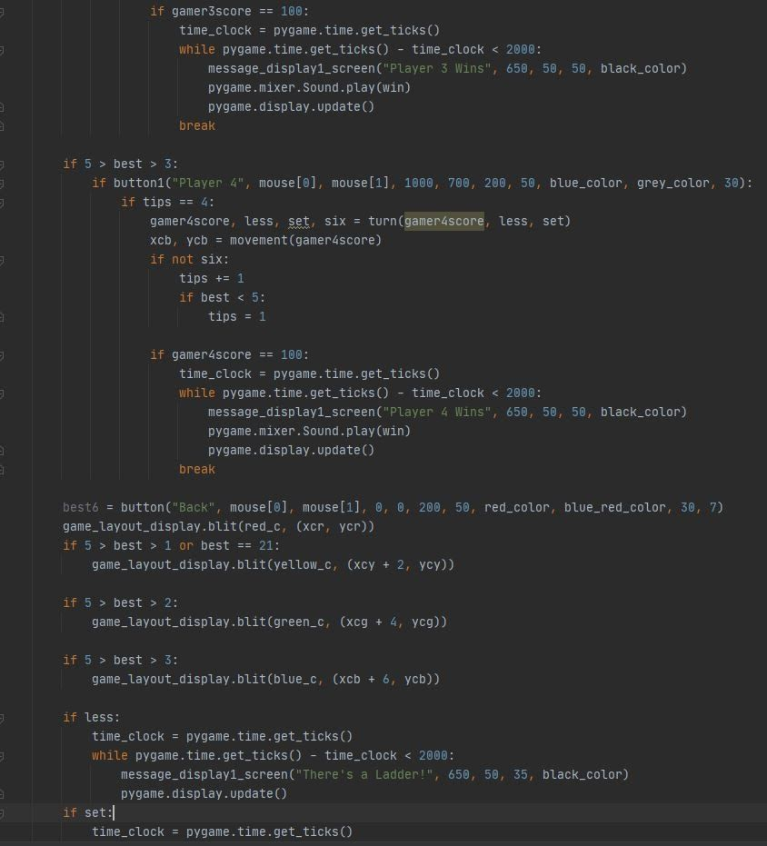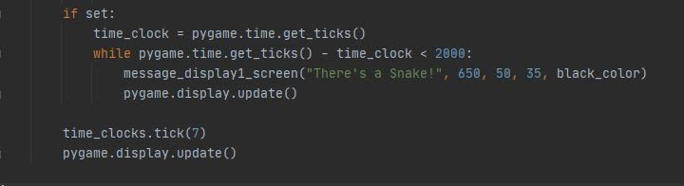

**2.4 The output of the program**

(*screenshots can’t be taken while running application so we used a camera).

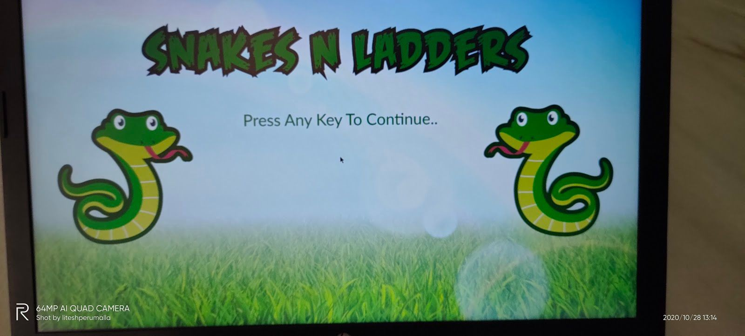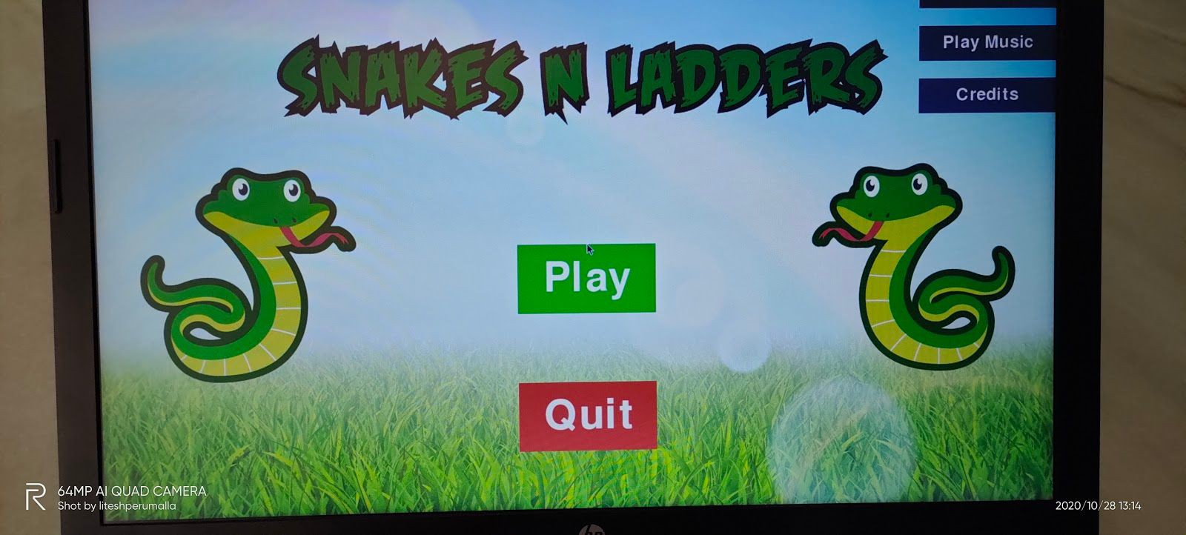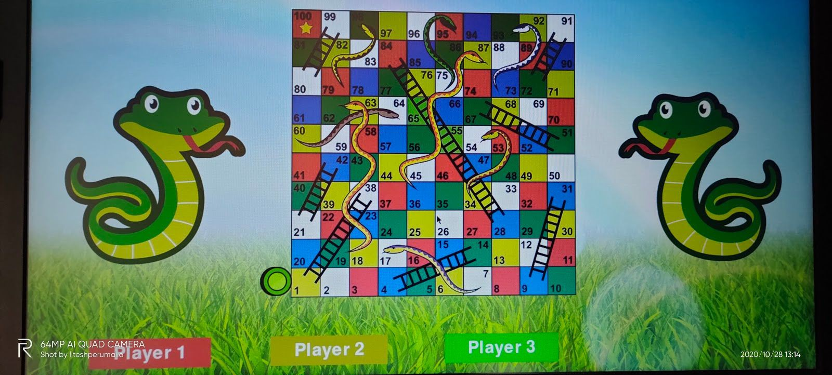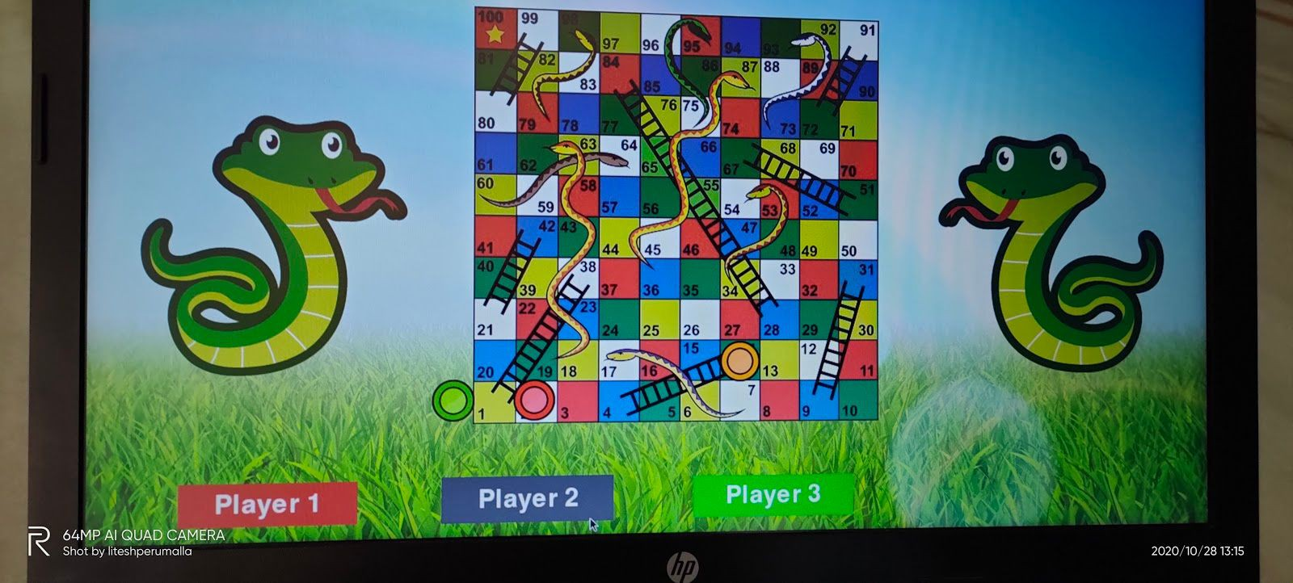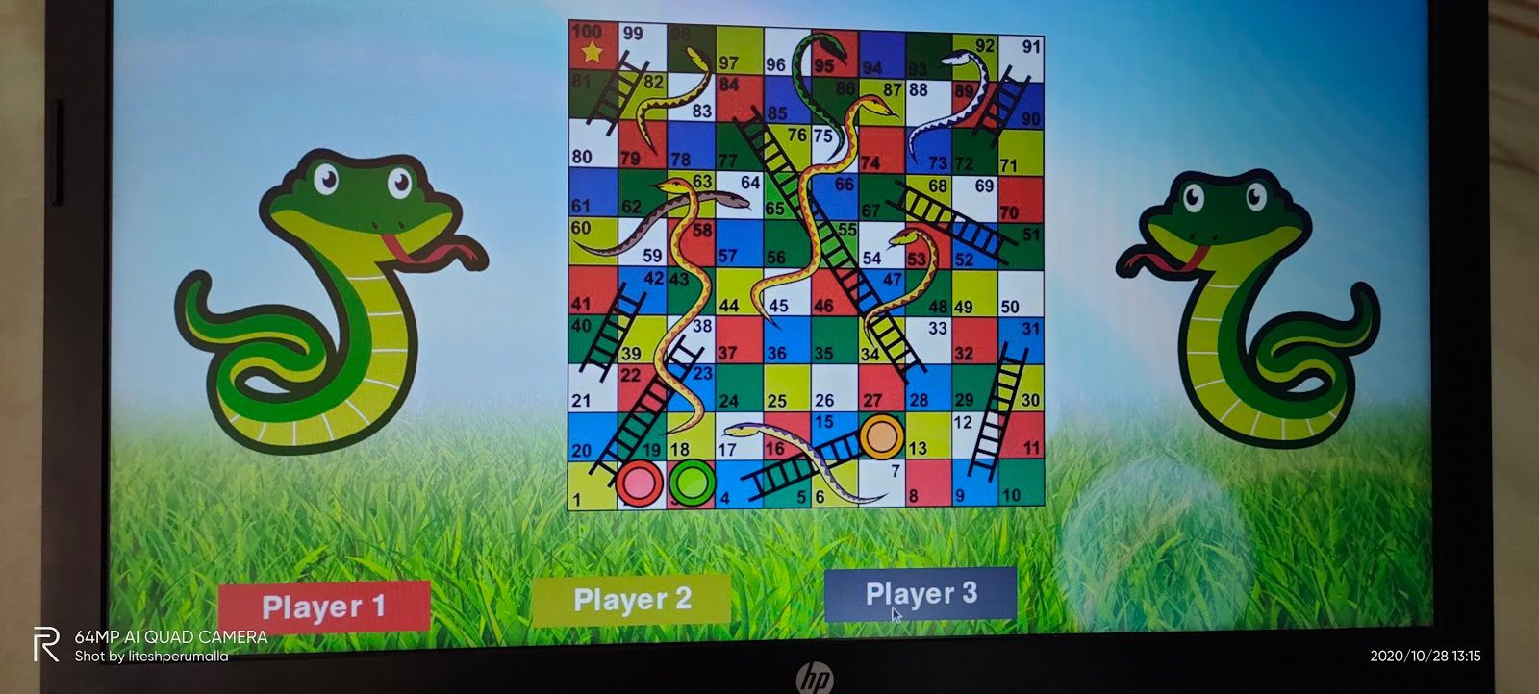

**2.5 Technologies and framework used.**

In the project, we used python IDE and pycharm compiler and used modules like pygame and random modules.

**2.6 SWOT Analysis**

**Strength**

Faster loading

Better user experience Background music Added multiplayer mode Nice graphics

**Weakness**

More storage required than other programs

May not work in other systems

Consumes a lot of memory

**Opportunities**

Better than other programs

Fewer programs

**Threats**

May cause lags and frame drops sometimes

Causes a negative impression

Emerging platform

Github link - https://github.com/liteshperumalla/python-project.git